Case Study of Visit Mexico

- Business Requirement
In developing its tourist industry, the Mexican government had three main goals:
- earning foreign exchange,
- creating employment,
- diverting internal migration toward tourism development poles.

iTreeni had joined hands with Mexican government to develop CMS solution which showcases tourist places, list of activities that can be performed on different places and also help tourists plan their trip.

- Feature Details
- Multilingual website.
- Fully responsive web design.
- Complex Google map operations for eye catching and easy-to-use "Play your trip" feature.
- Database optimization to get faster results and improve user experience.

- Technology
- Drupal 7, Drupal module development, MySQL, HTML5, CSS3, Bootstrap, Asana, GIT.

- Major Challenges :
- Work with virtual team.
- Timely delivery.
- Hard to understand requirement in absence of common language to communicate.
- Handle major data import/export operation of DB.

#1 Visit Mexico – Home
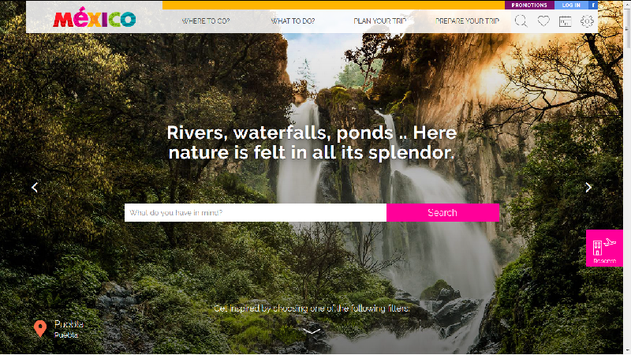

#2 Visit Mexico – Where to go page.
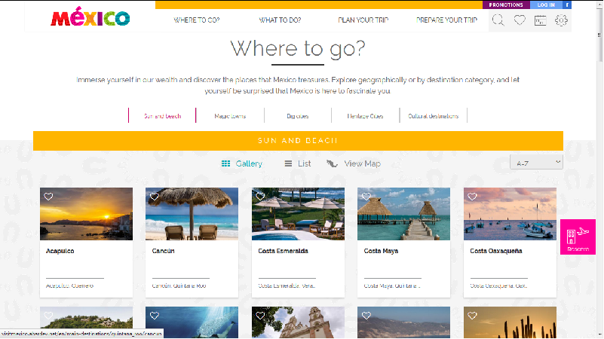
#3 Visit Mexico – What to do page.
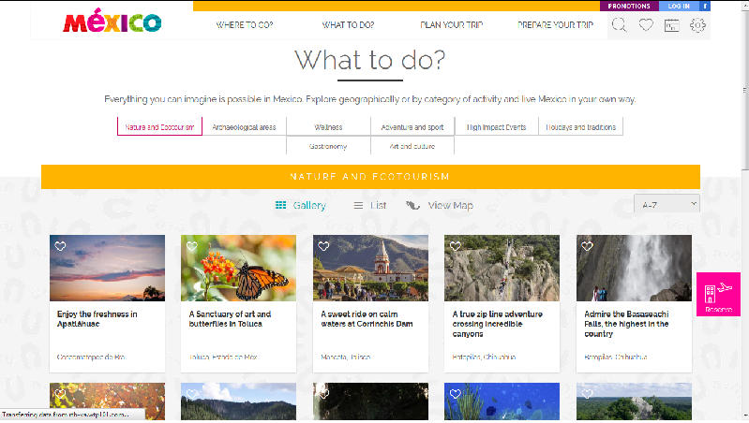

#4 Sitesafe – Add database details for schedule backup.

