Case Study of Site Safe Website

- Business Requirement
Sitesafe is designed to facilitate its users to schedule site and also database back up on daily, weekly or monthly basis. System helps to restore site and/or database to previous back-up when required.

- Feature Details
- Interactive Admin Management.
- Login with Facebook
- PayPal integration.
- Scheduled database and site back-up on daily, weekly and monthly basis.
- Providing restore points so when clicked it actually restores files on given FTP account.

- Technology
- Yii , jQuery, AJAX, MySQL, Eclipse, GIT.

- Major Challenges :
- Work with universal team.
- Timely delivery.
- RnD on space optimization. So next time system will only fetch modified files compare to last backup.
- RnD to create same folder structure for backed-up files.

#1 Made-2-Game – Home

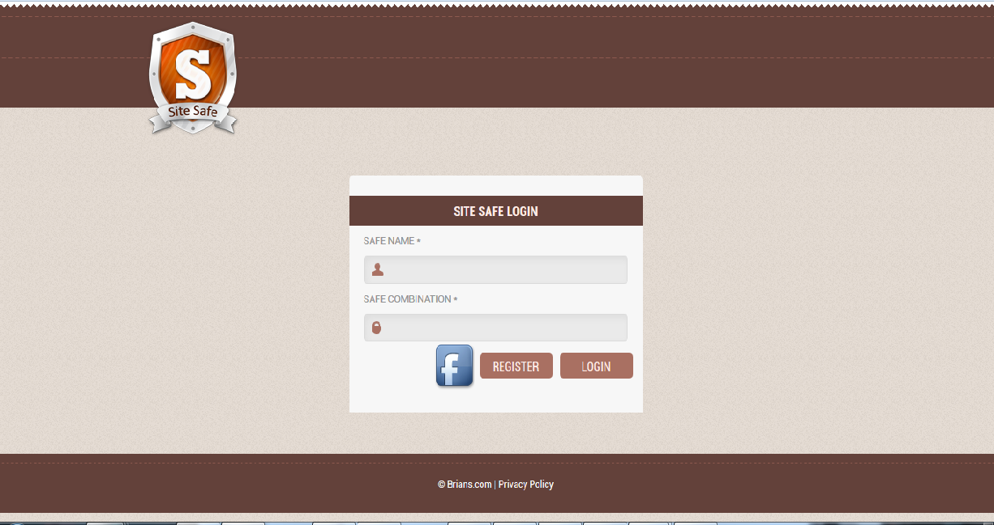

#2 Sitesafe – Add site details for schedule backup.

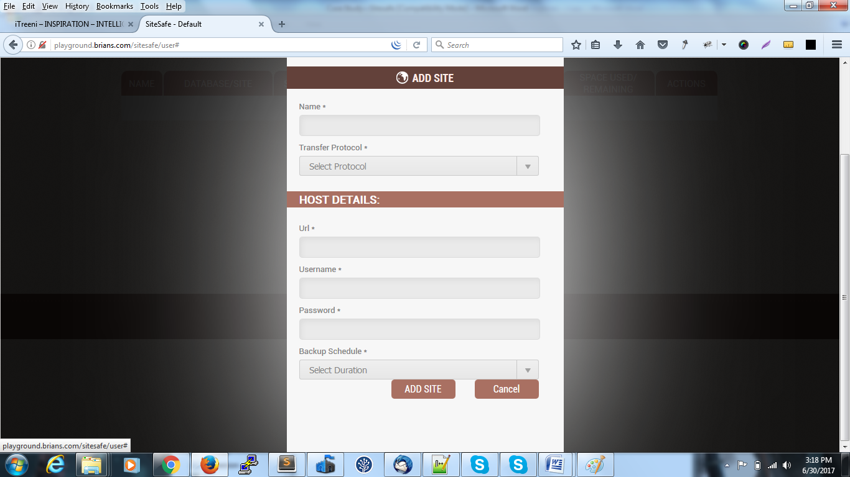
#3 Sitesafe – Add database details for schedule backup.

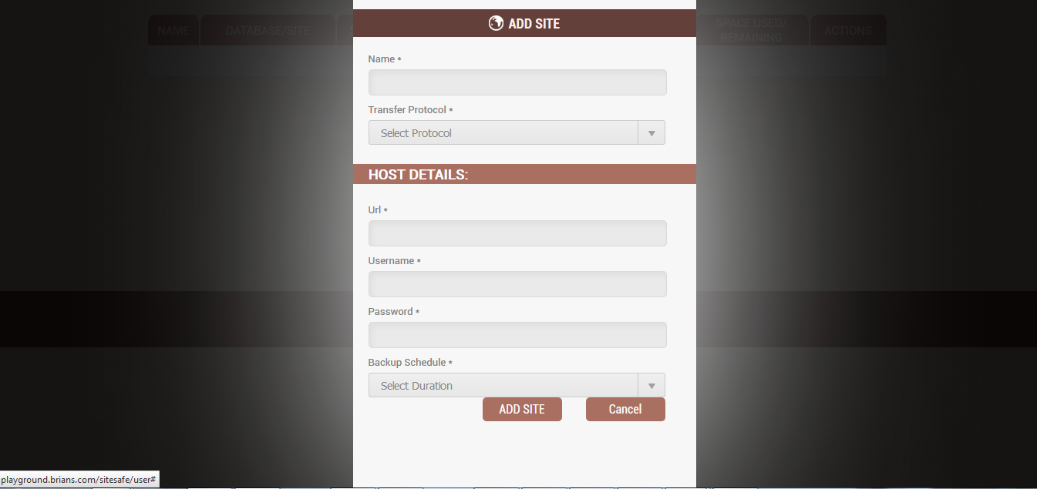

#4 Sitesafe – Add database details for schedule backup.

